13.6 Extracting of Al
Name: ____________________ Class: ____________________ Due date: 6.10
1. Which statement about the extraction of aluminium is correct? （ ）
A Aluminium is formed at the cathode during the electrolysis of aluminium oxide.
B Hematite is mainly aluminium oxide.
C Molten cryolite is used to raise the melting point of the aluminium oxide.
D Oxygen gains electrons at the anode during the electrolysis of aluminium oxide.

2. Aluminium is extracted by the electrolysis of aluminium oxide.
Which statement is not correct? （ ）
A Aluminium ions are oxidised at the cathode.
B Carbon dioxide is made at the anode.
C Cryolite is added to lower the melting point of the aluminium oxide.
D The electrodes are made from graphite.

3. Why is cryolite used in the extraction of aluminium by electrolysis? （ ）
A It changes bauxite to aluminium oxide.
B It decreases the melting point of the aluminium.
C It dissolves the aluminium oxide.
D It protects the anodes from corrosion.

4. Which statement about extraction of aluminium from aluminium oxide is correct? （ ）
A Aluminium is formed at the positive electrode during electrolysis.
B Pure aluminium oxide is dissolved in molten cryolite.
C Pure aluminium oxide is electrolysed using aluminium as the positive electrode.
D Pure aluminium oxide is heated with carbon to form carbon dioxide and aluminium.

5. Aluminium is obtained by the electrolysis of mixture of aluminium oxide and cryolite
Why is cryolite used? （ ）
A as a catalyst to speed up the process
B as a coolant to prevent the process getting too hot
C as a solvent for aluminium oxide
D as the main source of aluminium ions

6. Aluminium is extracted by electrolysis.
From which ore is aluminium extracted and at which electrode is aluminium deposited during electrolysis? （ ）
 | ore | electrode
A | bauxite | negative
B | bauxite | positive
C | cryolite | negative
D | cryolite | positive

7. Aluminium is extracted by electrolysis of a mixture of aluminium oxide and cryolite.
Which statement is not correct? （ ）
A The electrodes are made from graphite.
B The formula for aluminium oxide is ${Al}_{2}O_{3}$
C The purpose of the cryolite is to lower the melting point of the mixture.
D The reaction taking place at the anode is ${Al}^{3+}+3e^{−}→Al$

8. Aluminium is produced by the electrolysis of aluminium oxide dissolved in molten cryolite.
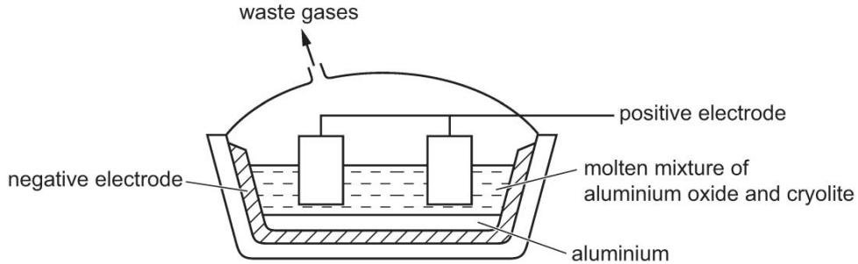
a.Name the ore of aluminium which mainly consists of aluminium oxide..............
b.Give two reasons why the electrolysis is done using a molten mixture of aluminium oxide and cryolite instead of molten aluminium oxide only.
1.....................................................................................................................................
2.....................................................................................................................................
c.Write ionic half- equations for the reactions occurring at the electrodes.
Positive electrode .......................................................................................................
negative electrode........................................................................................................
d. The anodes are made of carbon and have to be replaced regularly.
Explain why the carbon anodes have to be replaced regularly.
.......................................................................................................................................
......................................................................................................................................
9. Aluminium is obtained from purified alumina, ${Al}_{2}O_{3}$ , by electrolysis.
Alumina is obtained from the main ore of aluminium. State the name of this ore.
...................................................................................................................................[1]
Describe the extraction of aluminium from alumina. Include the electrolyte, the electrodes and the reactions at the electrodes.

10. Aluminium is extracted from aluminium oxide by electrolysis.
a.Why is aluminium not extracted by heating aluminium oxide with carbon?
..................................................................................................................................[1]
Aluminium oxide is an ionic compound with a high melting point.
b.Complete the dot-and-cross diagram to show the electron arrangement in one of the oxide ions present in aluminium oxide. Include the charge on the oxide ion.
One of the aluminium ions is shown.
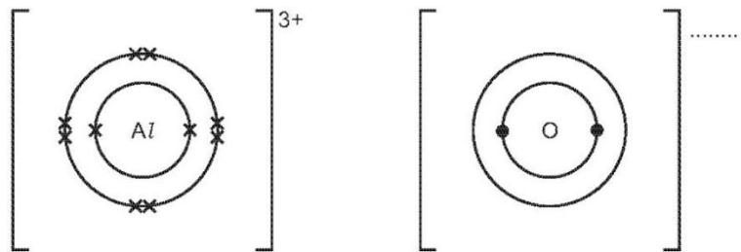[2]
c.The melting point of aluminium oxide is above ${2000}^{∘}C$
Explain why aluminium oxide has a high melting point.
d.The major impurity in bauxite is iron(III) oxide. Iron(III) oxide is basic, aluminium oxide is amphoteric.
Explain how aqueous sodium hydroxide can be used to separate them.
.......................................................................................................................................
...................................................................................................................................[2]

